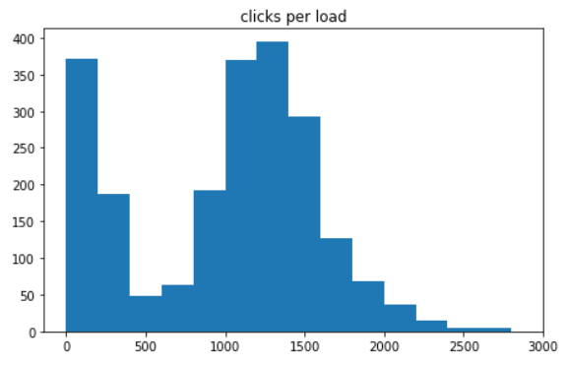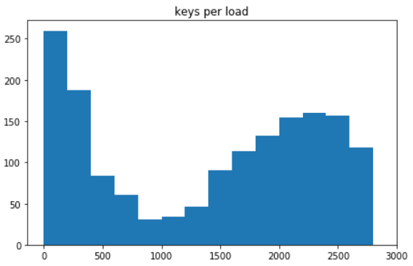During my time at CoLane Logistics, a Chicago tech startup, I used Python to extract and count the number of clicks and keystrokes per brokerage transaction from the user logs of a proprietary application. These metrics were used by the CoLane Logistics executive team to estimate the labor cost per transaction.

*Keystrokes per load:* Histogram of the number of keystrokes required to complete a brokerage transaction. The x-axis is the number of keystrokes required to complete a brokerage transaction, and the y-axis is the number of transactions. The graph shows low-labor transactions under 500 keystrokes, and high-labor transactions spanning 1,500-2,800 keystrokes.

*Clicks per load:* Histogram of the number of clicks required to complete a brokerage transaction. The x-axis is the number of clicks required to complete a brokerage transaction, and the y-axis is the number of transactions. The graph shows low-labor transactions under 400 clicks, and high-labor transactions spanning 800-1,600 clicks.

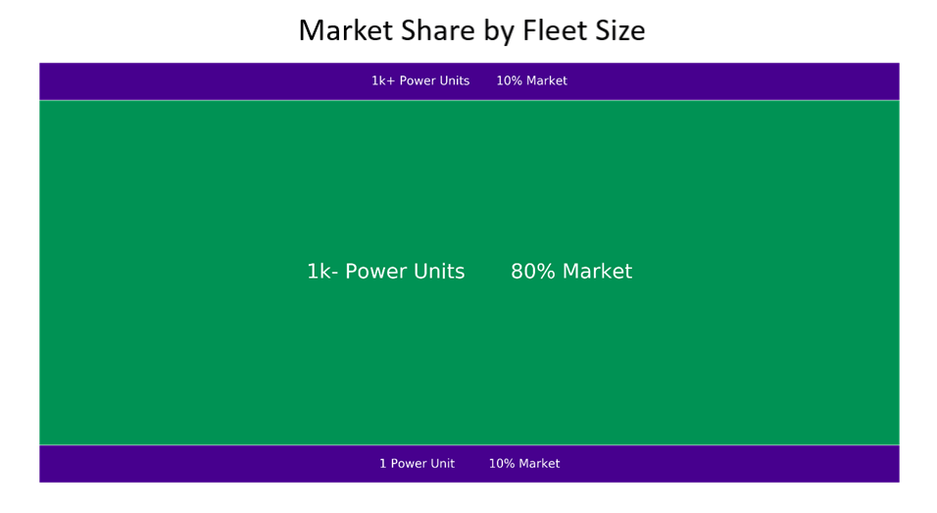Consisting of 200,000 trucking companies, the US long-haul trucking market is highly fragmented. Most of the market is controlled by medium-sized carriers (green, below) owning less than 1,000 trucks (or "power units", below) leaving room for consolidation. I extracted these truck counts from FMCSA roadside truck inspections data using Python. The data visualizations were used by the CoLane Logistics executive team to pitch market opportunity to investors.

*Market Share by Fleet Size:* Breakdown of market share by logistics company size. 80% of the market share is controlled by trucking companies owning 2-999 trucks (or "power units") per company. Just 10% of market share is controlled by large companies having 1,000+ trucks per company, which signals an opportunity for consolidation in the middle market.

* *Market Share by Fleet Size:* Breakdown of market share by trucking company size. 33% of the market share is controlled by trucking companies (or "carriers", below) owning 10-99 trucks per company. However, these companies make up just 7% of the total number of trucking companies, which signals an opportunity for brokerage services.

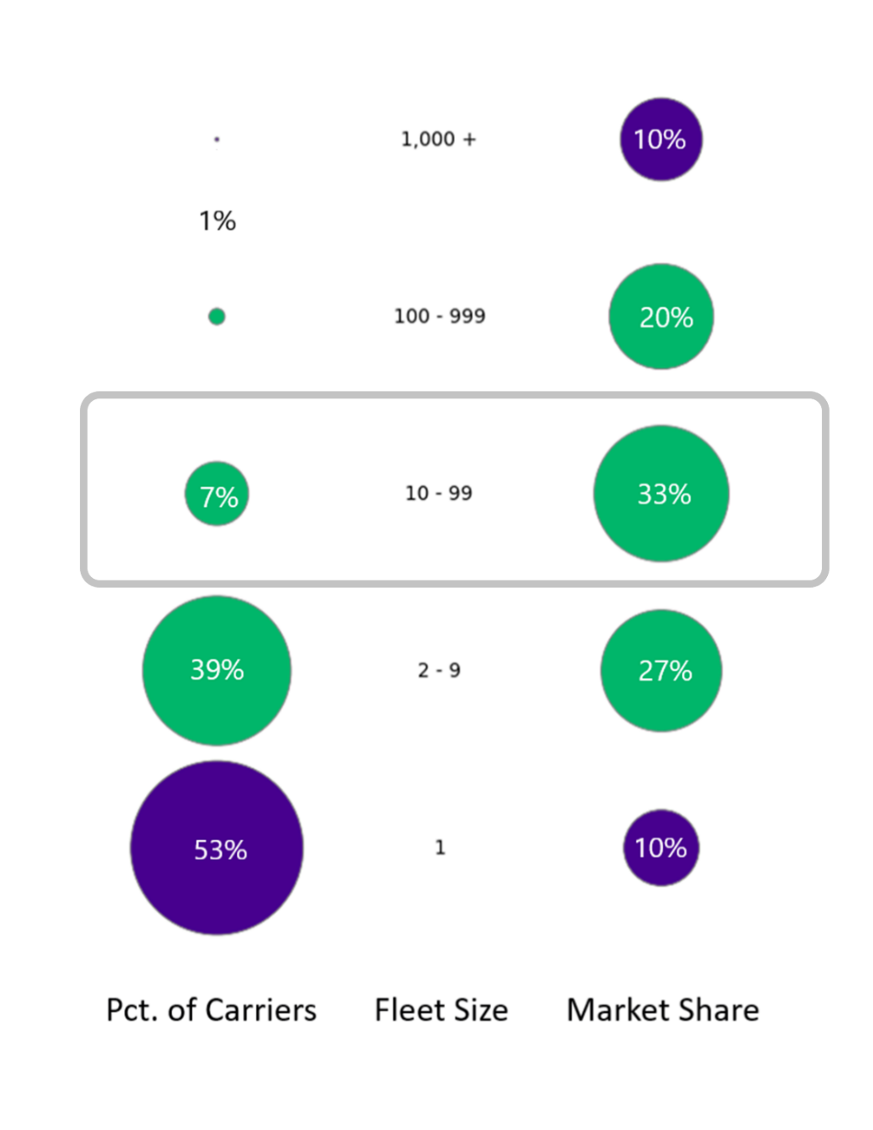

* *Market Share by Fleet Size:* Breakdown of market share by trucking company size. 10% of the market share is controlled by companies owning just 10-19 (or "10s"of) trucks per company, which is the target market of CoLane Logistics.

